Table of Contents

1. Setup Guide: Getting Started with Selenium and C# 2

2. How to Install Visual Studio 2

3. How to create Project in Visual Studio 8

4. How to Add Chrome driver to Selenium C# Project using Visual Studio 13

5. How to Add Gecko Driver to Selenium & C# Project using Visual Studio 15

6. How to write the first test using Selenium, C# and Nunit using Visual Studio IDE 17

# Setup Guide: Getting Started with Selenium and C#

Before running a test with Selenium and C#, we need to complete the basic prerequisites.

1. Install Visual Studio
2. Create Selenium C# automation framework .NET Core 6.0 from scratch using Visual Studio
3. Create Project, Add class for pages and Test
4. Add Chrome driver to Selenium C# Project using Visual Studio
5. Add Gecko Driver to Selenium C# Project
6. How to write the first test case using Selenium, C# and visual studio

# How to Install Visual Studio

Visual Studio IDE is available in both free and paid versions. The community version of Visual Studio is free.

* Download Visual Studio Community Edition from [**Microsoft official website**](https://visualstudio.microsoft.com/downloads/)**.  
  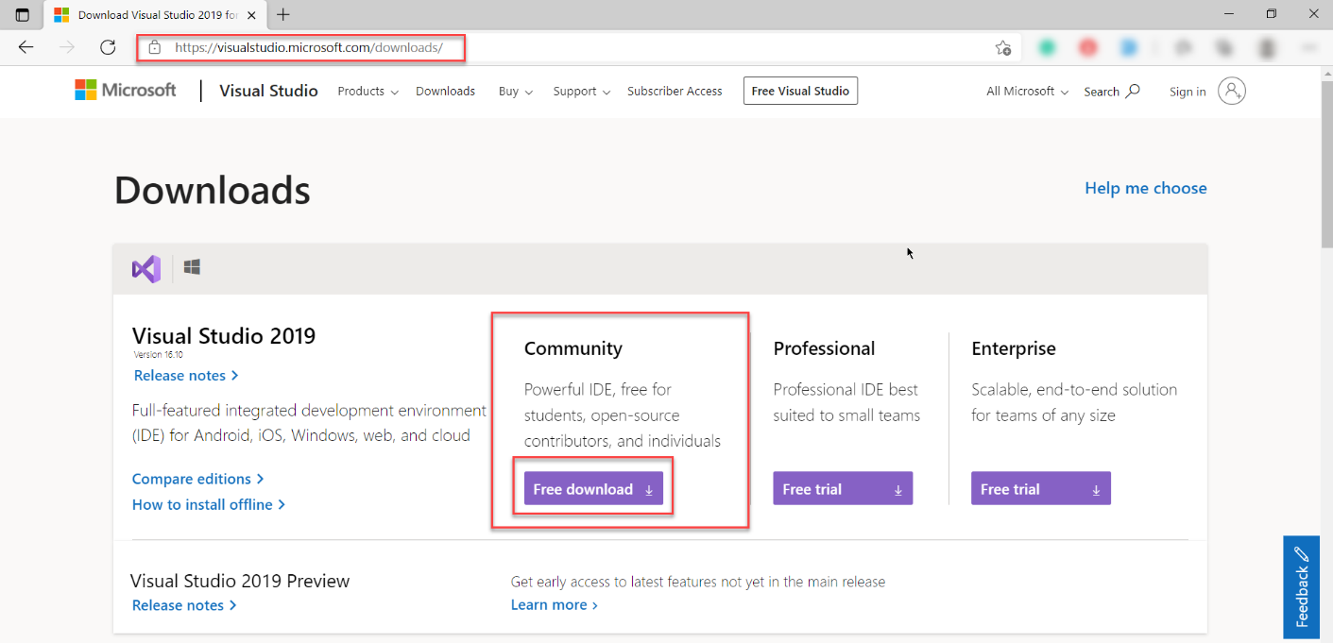**
* Click on **Free Download**, and the **.exe** file will be downloaded.

Click on the .exe file to start the Visual Studio Installer.

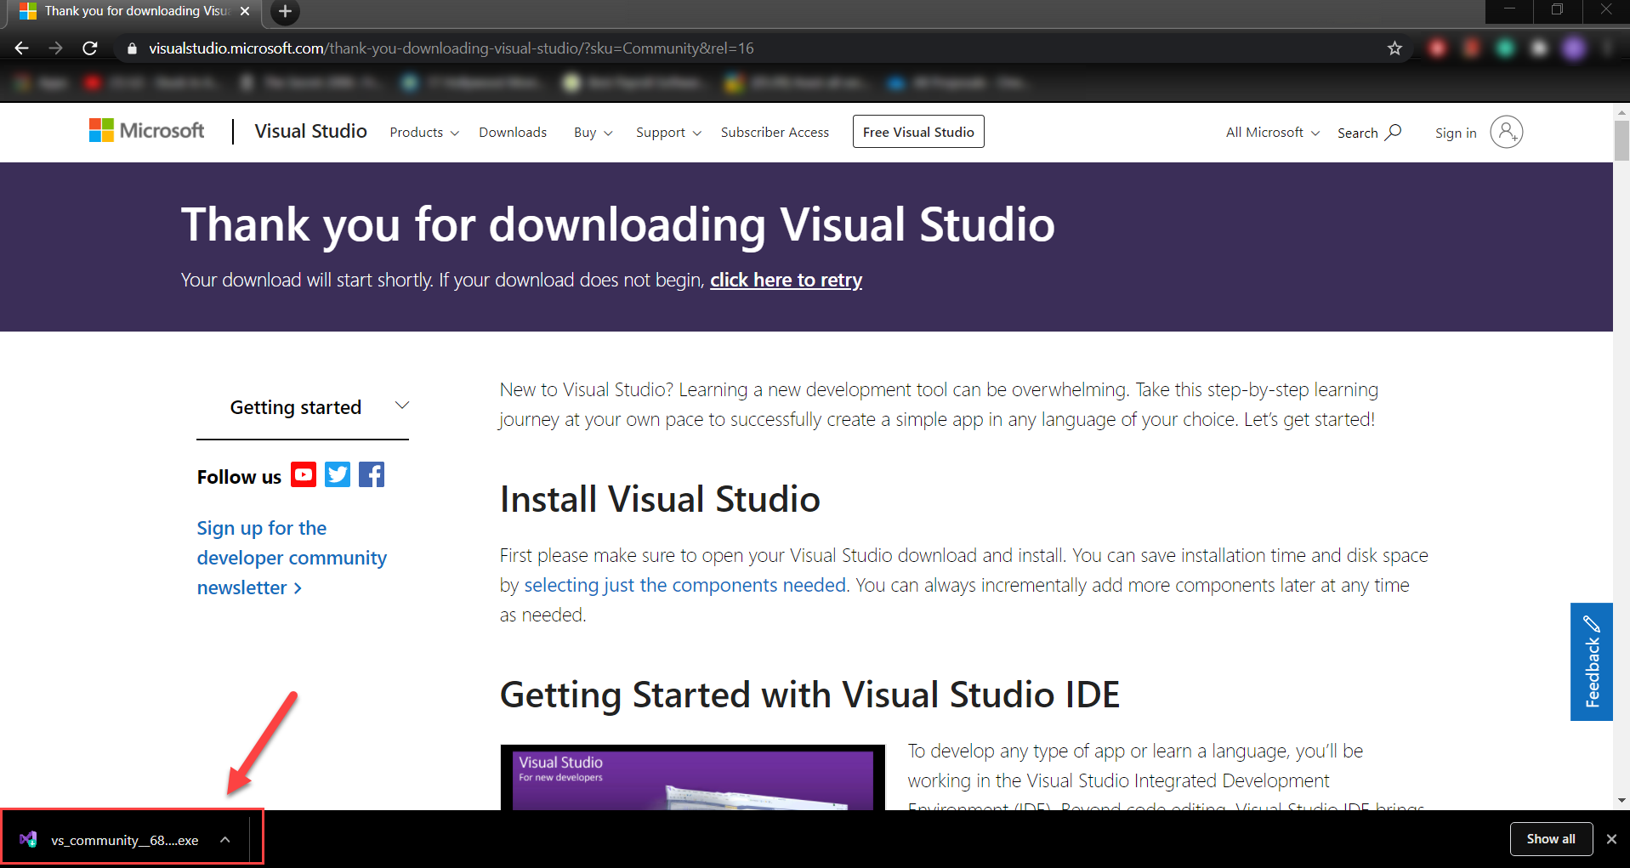

Click on the installer file**,**the**Privacy and License Terms** window appears, click on **Continue** to start installation.

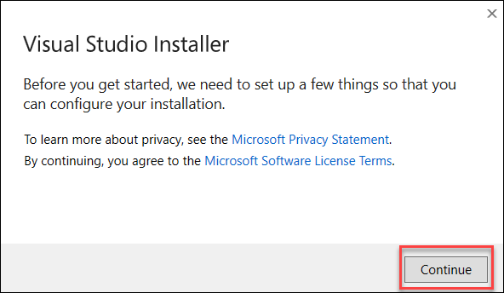

* Visual Studio Installer downloads and prepares Visual Studio for installation.  
  ***Note: This is Visual Studio Installer, not the Actual Visual Studio***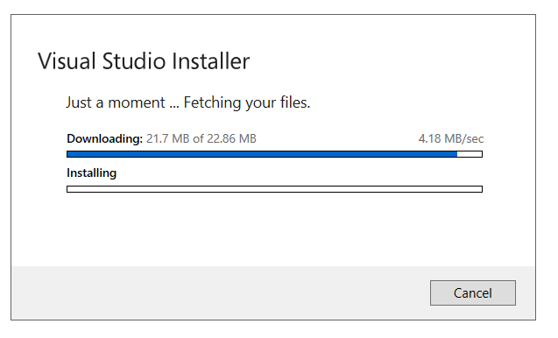

Once the Preparation is complete, the **Visual Studio installation window** appears. Users will have to choose a set of tools. To build an automation framework one can choose the **Asp.net and Web development** option. Click on **Install** to proceed.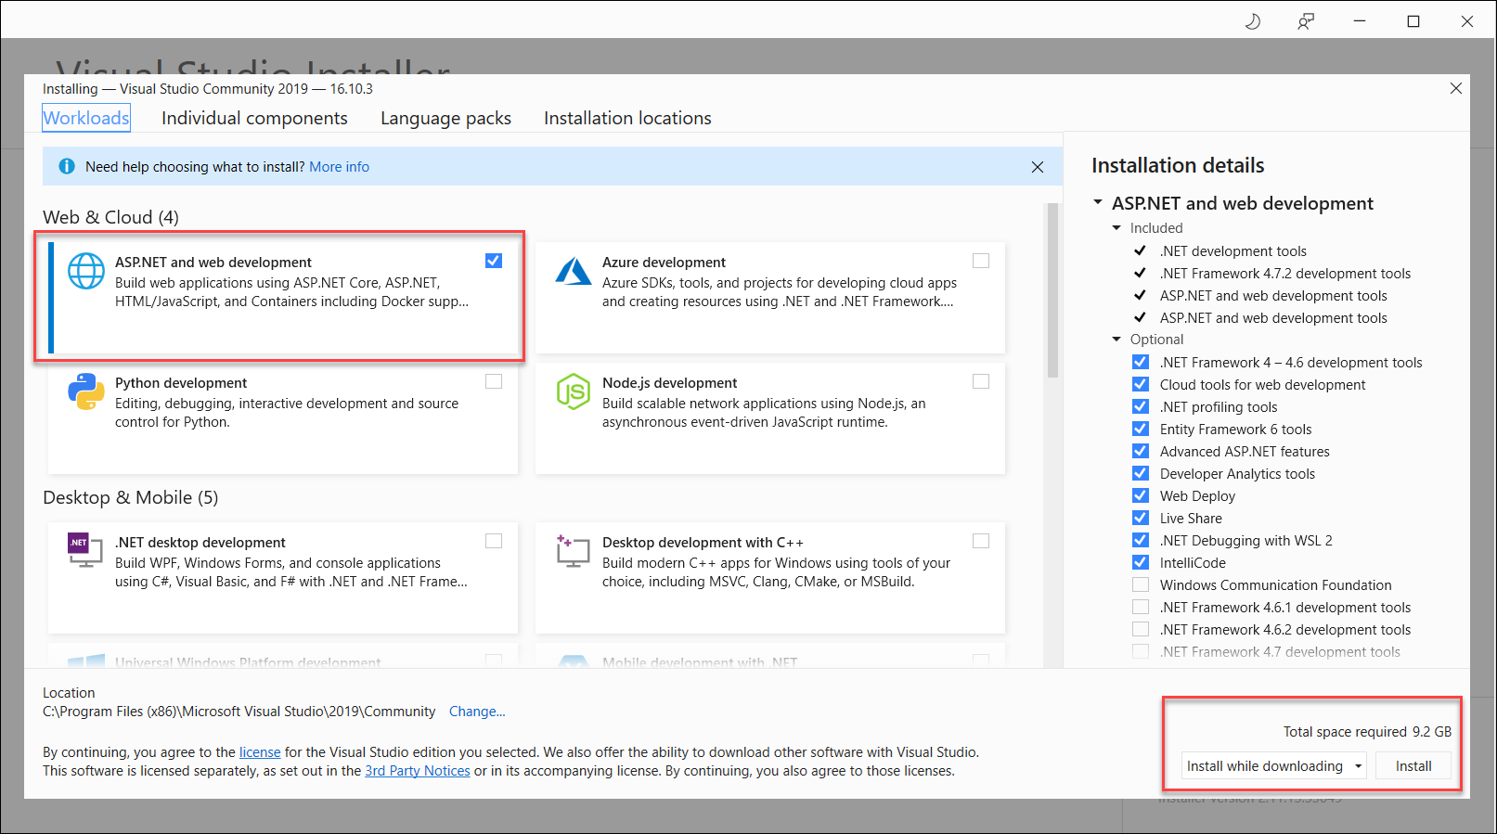

* Installation begins and its progress percentage will be shown accordingly.  
  ***Note: The installation takes some time depending on the internet speed.***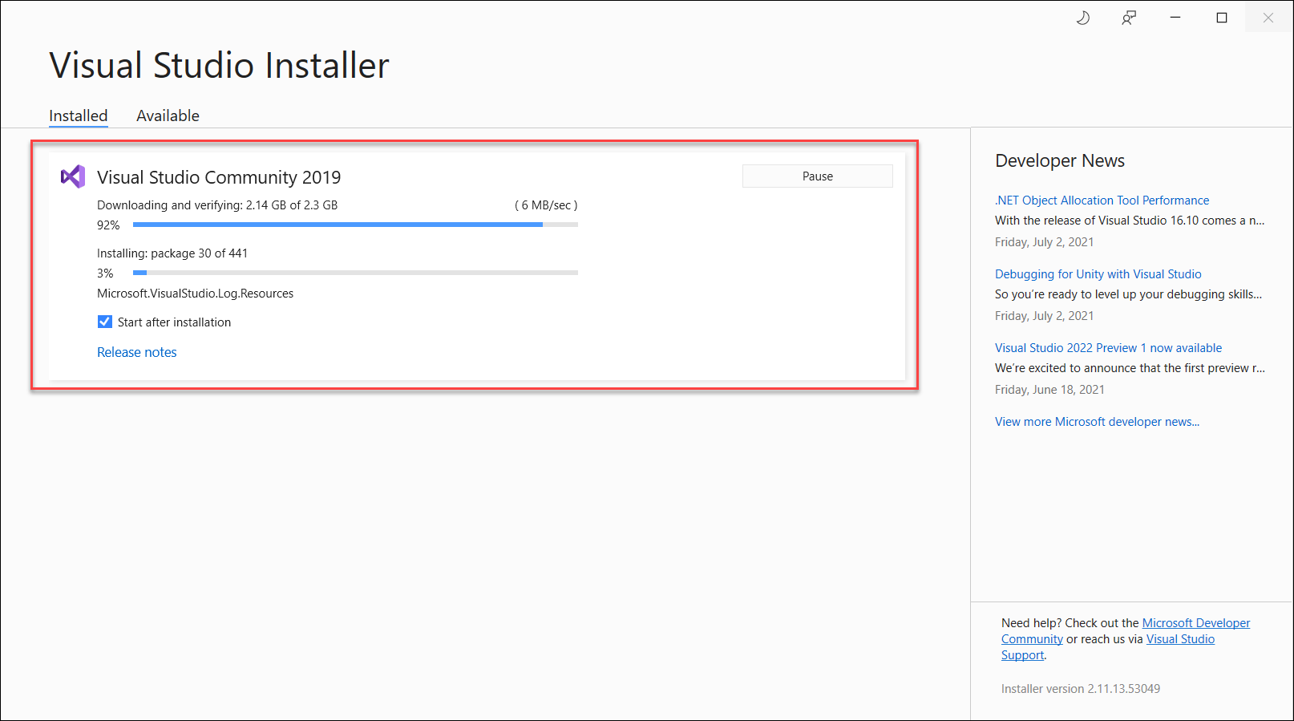
* Once the installation is complete, **the Restart pop up window** appears. Click on **Restart.**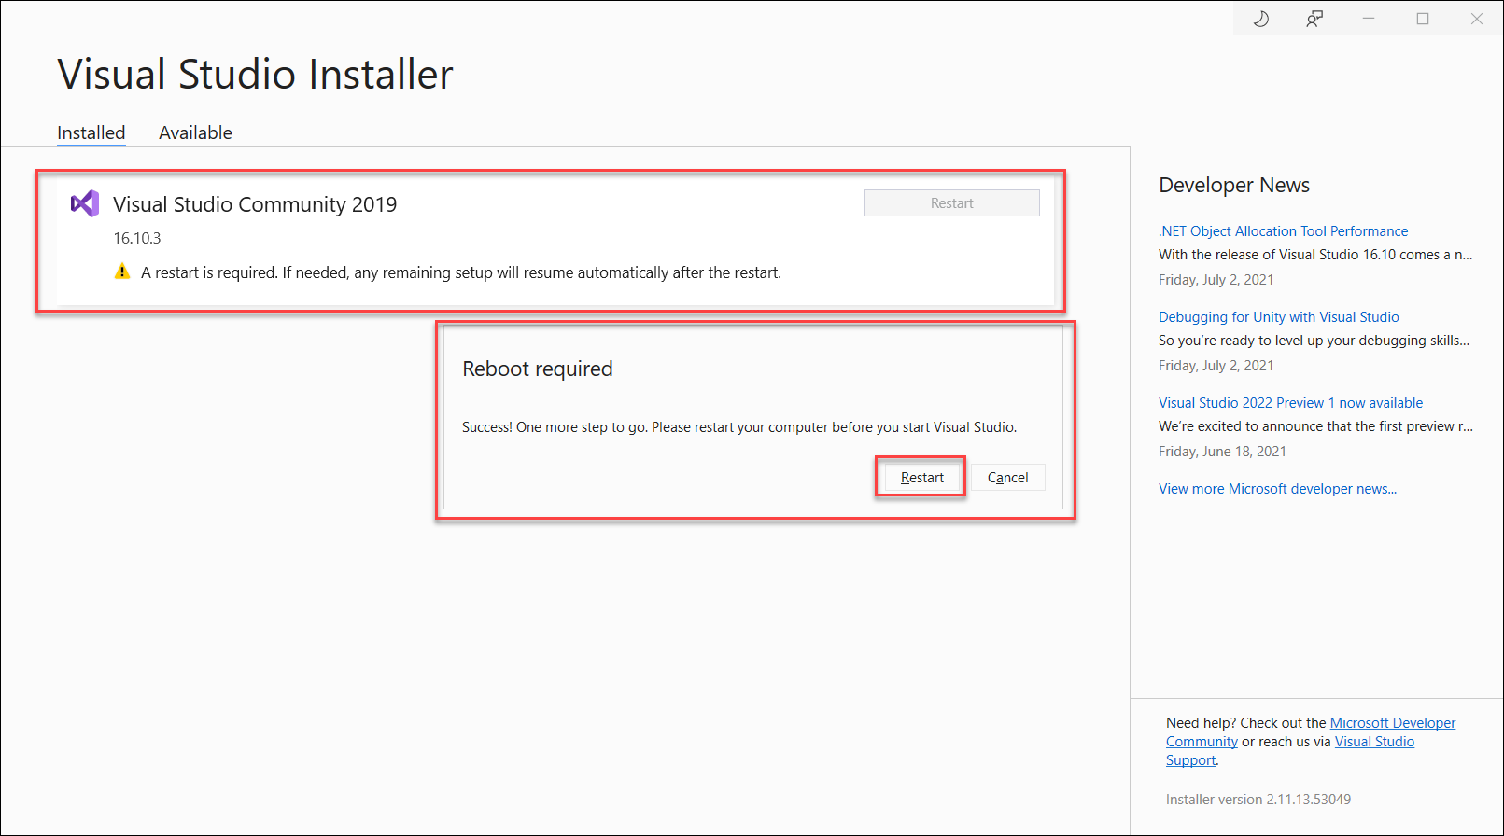
* After a successful restart of the system, the **Visual Studio setup pop up** will appear. Click on **Not now, Maybe later**.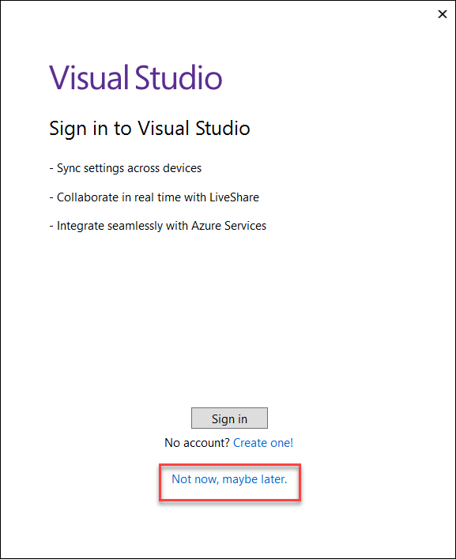
* ***Note****: Sometimes, after restart the above window doesn’t appear. If it doesn’t appear automatically just Open Visual Studio from the Windows Start Menu.*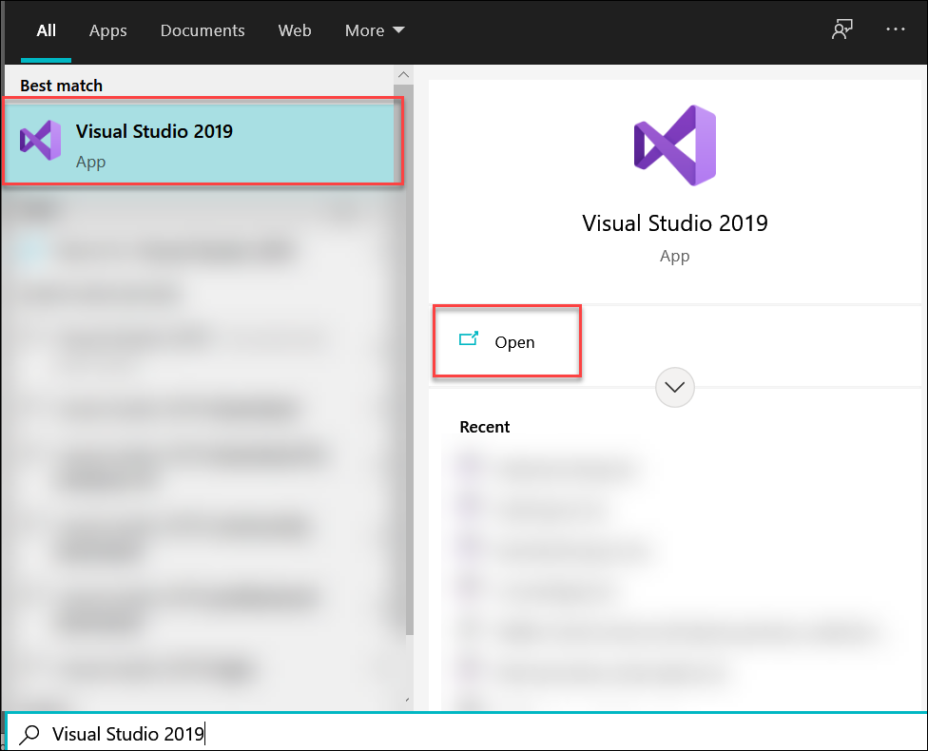
* **Choose a Theme for Visual Studio**, and click on **Start Visual studio.**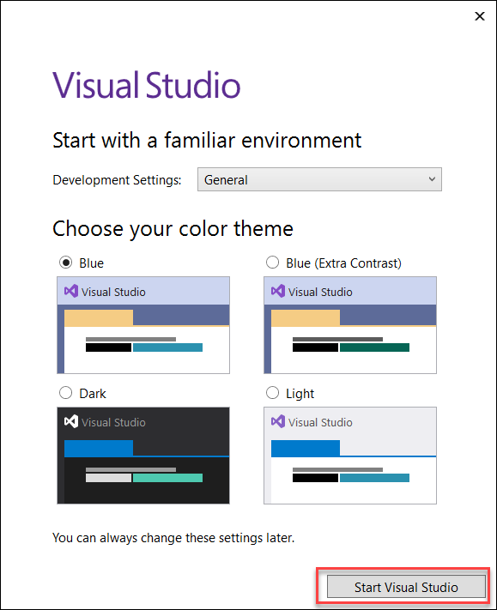
* Visual Studio prepares settings for First Use.  
  ***Note:****This stage takes some time to finish.*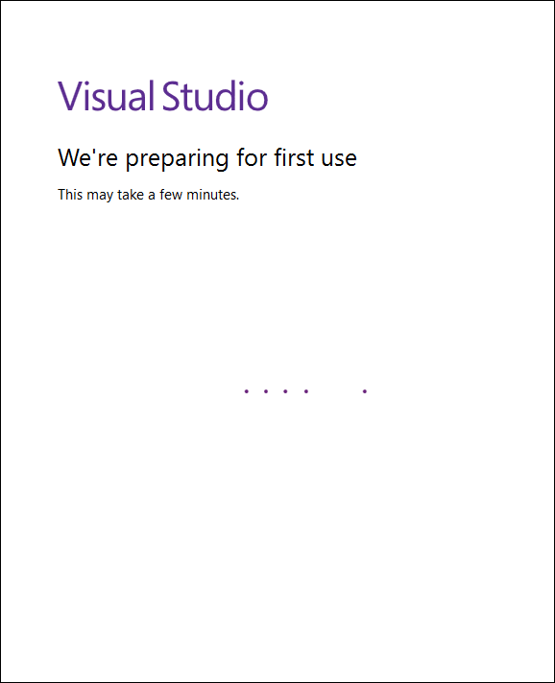
* Once the above step is completed, the Get Started Window opens.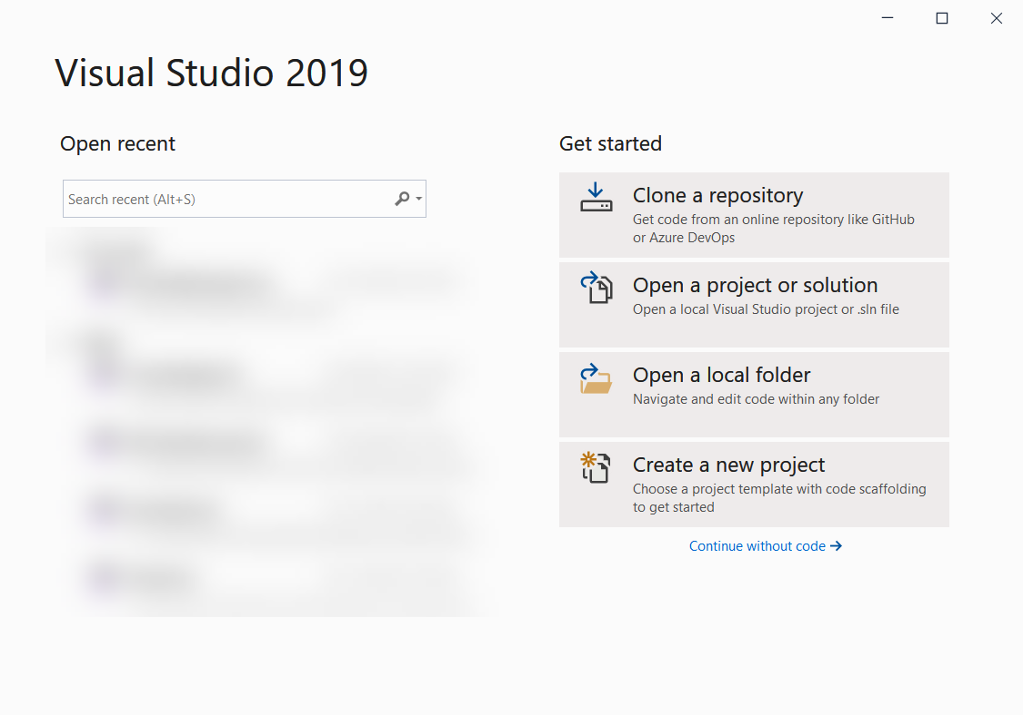
* Visual Studio Installation is complete.

# How to create Project in Visual Studio

Click on the file menu and select New ->Project

Step 9) Select the project type as Class Library (.NET Framework) and click on Next button

**Enter the project name and click on next button**

**A project with the name is created**

**Right click on the References and choose Manage Nuget Packages**

**Click on Browse tab, search for the particular reference ….**

**Click on Install the reference to be added to the project.**

**Click on Ok button to install the reference.**

**Check the status whether it has been successfully installed.**

**Under the installed tab check the installed reference is displayed.**

**Add the folder to the project by right clicking on the project select Add-> New folder**

**Adding a class to the project -right click on the project and select Add->New Item**

**Adding class to the folder right click on the folder and select Add-> New Item**

**In the Add New Item Window select the Class and type the Name of the class and click Add**

# How to Add Chrome driver to Selenium C# Project using Visual Studio

* Navigate to **Solution Explorer** in Visual Studio.
* Right click on the Project (ex: Selenium sharp)  
  ***Note:****Right Click on the Project Name, not on the Solution Name.*
* Click **Add.**
* Click**New Folder.**
* Name the new folder **drivers.**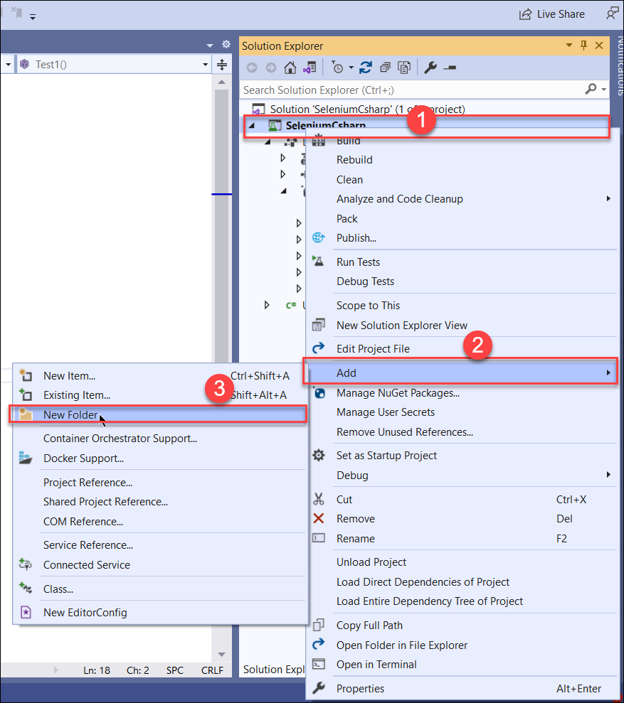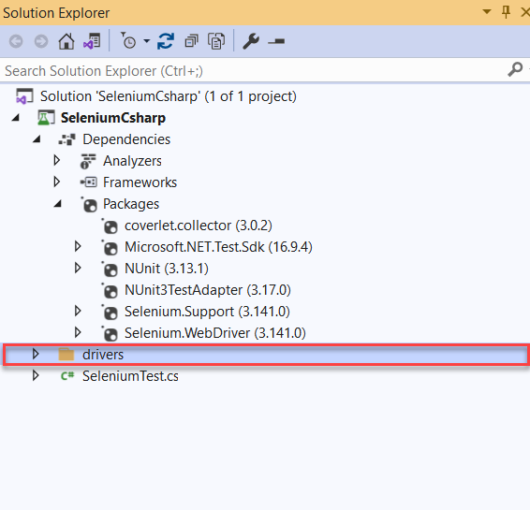
* Download ChromeDriver by navigating to the [Chromium webpage](https://chromedriver.chromium.org/downloads).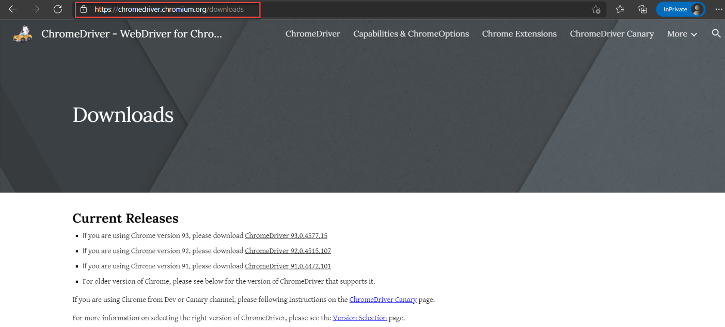
* Click on Chrome Driver <XX.XX.XXX>.
* A new web page will open up and ask for the target Operating System (Windows, in this case).
* Click on the right option and Chrome Driver will be downloaded as a Zip file.
* 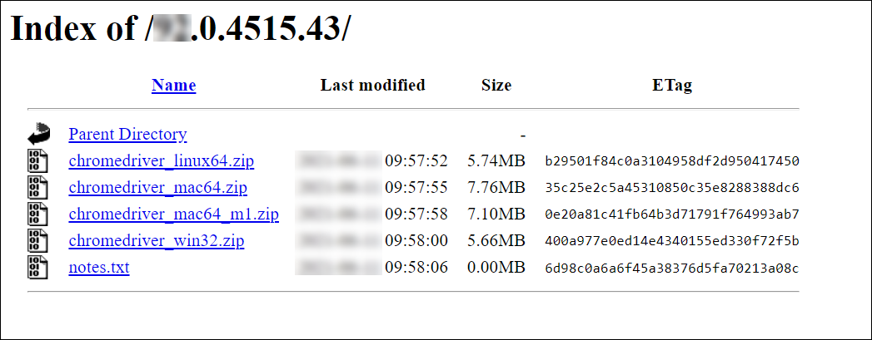Extract the zip folder to the desired project location: the previously created folder **drivers**, in this case. To do that, simply right click on the **drivers** folder in Visual Studio, and choose **Open Folder** in **Explorer.**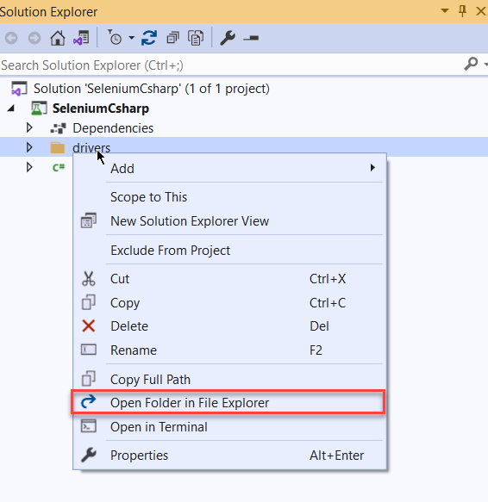

This will open the **driver**folder in Windows File Explorer. Now, the ChromeDriver zip file is downloaded to the required location, extract the ChromeDriver zip here.

**Alternatively,** right click on zip file > Click on Extract All > Specify folder location.

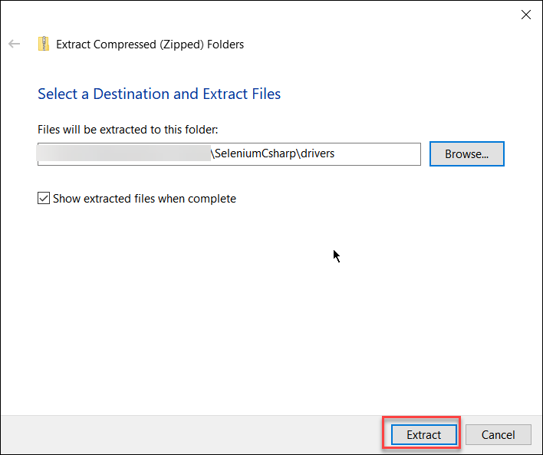

After extraction, the **driver’s** folder should contain **chromedriver.exe**.

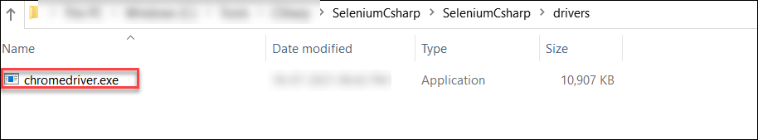

# How to Add Gecko Driver to Selenium & C# Project using Visual Studio

***Note:****This step is required to run tests on Firefox.*

* Navigate Gecko driver Download web page:  
  – Navigate to [Mozilla Github](https://github.com/mozilla/geckodriver)  
  – Click on **Releases** under **Downloads**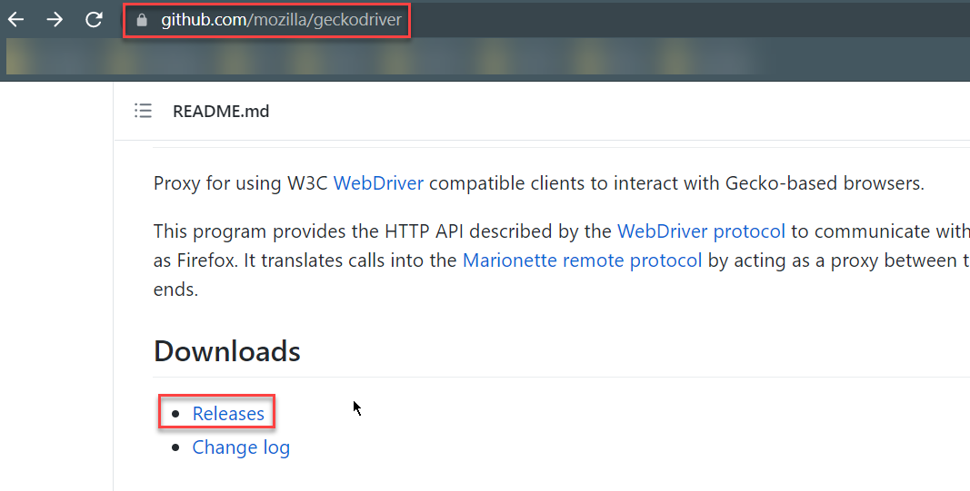

* Choose the correct platform for GeckoDriver and download.  
  – In the Releases page, scroll down to the **Assets** section.  
  – Choose the desired GeckoDriver for the Operating System being used (Windows, in this case).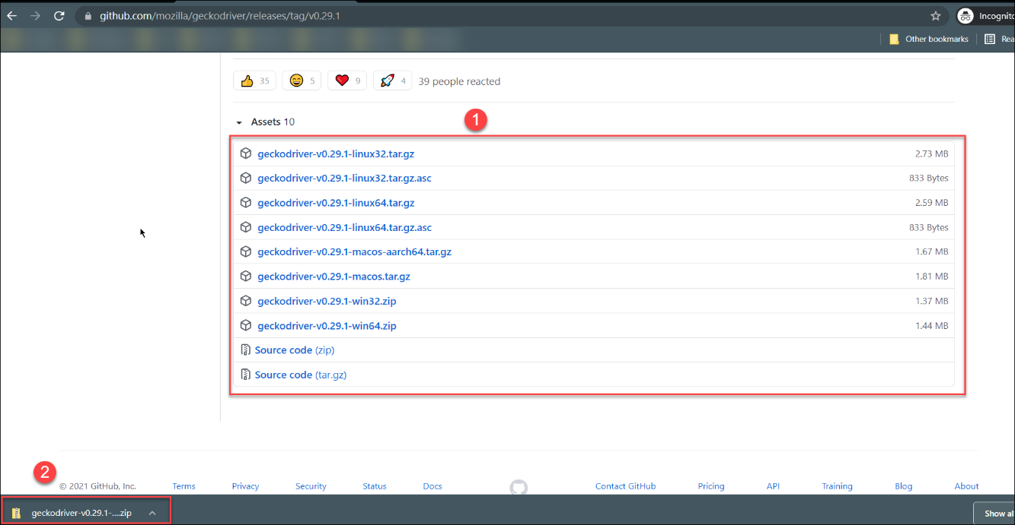
* After completion of Step 2, the zip file containing **geckodriver.exe** will be downloaded.
* Extract the GeckoDriver to the **drivers** folder created earlier. **Note:***Step 4 is similar to Chromedriver download. Simply extract geckodriver.exe and place it in drivers folder.*After completing this step, the drivers folder should contain two .exe files namely **chromedriver.exe and geckodriver.exe**.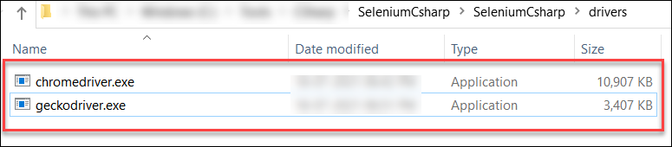

# How to write the first test using Selenium, C# and Nunit using Visual Studio IDE

.

Double click on the class(Sample ) and starting writing the tests.

